Name: Ethan Becker
Student ID: ebecke10
Date: 10/8/25

Instructions: Answer the following questions using complete sentences. You should use these questions to have a written discussion about the website you are going to design for the topic you submitted for Project Submission 1.

- Website Goal (10 points)
Describe the goal of your website in one or two sentences.
The mission of my website is to appeal to prospective employers in the game development industry. Each page will highlight a different part of my portfolio to grab employers’ attention, demonstrate my technical and creative skills, and make it easy for them to contact me directly.

- What results do I want to see? (20 points)
- List the page name (that will be used in the nav section, e.g. Home, Yurts, Contact, etc.) For the project assignment, you will create 4-6 pages (10 points)
- Provide a brief description for each of those. 4-6 pages. (10 points)

Home:
The Home page will serve as a welcoming landing page that introduces me, features a short professional bio, and provides quick links to other sections. It will also include contact information and a brief overview of my mission as a gameplay programmer.
Design Portfolio:
This page will showcase my design work, including level design layouts, gameplay flowcharts, and user experience planning. Visuals such as images, concept sketches, and short GIFs will help demonstrate my creative process.
Programming Portfolio:
This section will focus on my programming skills. It will include examples of scripts, coding challenges, and snippets of in-game systems I have developed. It may also include short videos showing my code in action.
Documentation:
This page will display excerpts from my game design documents, postmortems, and project planning materials. It will highlight my ability to plan, communicate, and organize development work effectively.
Game Credits:
This section will list the games I have contributed to, with my specific roles and responsibilities in each project. It will include links to the games (if playable) or trailers that show my contributions.

- Insert a sitemap below. (10 points) Most websites follow a hierarchical organization where the landing page is the Home page (the index.html file). This means the Home page opens when visitors enter your website's URL. Use a computer application (word process, PowerPoint, draw.io, etc.) to draw a sitemap of your website that shows the hierarchy of pages and relationship between the pages. If you are using a computer application to create a site map and save as a .gif or .jpg file (within the application or using Print Screen) and insert them, with Insert screenshot function, below.

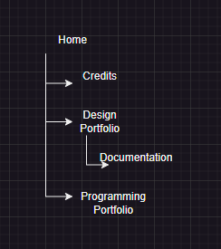

- What information do I need? (20 points)
List where you will obtain the content (facts, text, graphics, sound, video, etc.) for the web pages you listed above. If the information is from a website, list its url. Can’t just answered will google it. (10 points)
List out this information separately for each page you listed in Question 2. (10 points)

Home Page:
- Profile photo (taken by my girlfriend)
- Personal bio (short tid bit I will write about myself)
- Contact info and social media links (LinkedIn, GitHub, Itch.io)
- Banner image or background (custom graphic created in Photoshop or canva)
Design Portfolio:
- Screenshots and concept art from personal projects
- Design flowcharts and sketches (created in sketch.io, or canva)
- GIFs or short clips showing level design (recorded in OBS Studio)
Programming Portfolio:
- Code snippets and examples from GitHub repositories
- Video clips demonstrating in-game functionality (recorded in OBS)
- Links to GitHub, Itch.io, or project documentation
- Screenshots from development builds
Documentation Page:
- Extracts from my Game Design Documents (from my project archive)
- Postmortem summaries from completed projects (from my project archive)
- Diagrams from development planning tools like Taiga or Jira (from my project archive)
Game Credits Page:
- Game titles, development roles, and team credits from my own records
- Links to playable builds on itch.io
- Screenshots or promotional images from each game

- What color scheme will you use for your site? (20 points)
Go to https://www.realtimecolors.com/ and select a color scheme you like. Play around with the different types of color combinations. When you find one that you like, click the Export button (the third button from the right).

Include those CSS styles in your project assignment’s CSS file as global variables inside the :root selector. For reference, please refer to the example at https://www.w3schools.com/css/css3_variables.asp.

Take a screenshot of the entire screen and paste it in the space below. Below is an example. The color scheme showed in the bottom of the screenshot is worth 10 points, and the CSS style code, in the center of the screenshot, is also worth 10 points. Please submit a screenshot that includes both the color scheme and the CSS styles.
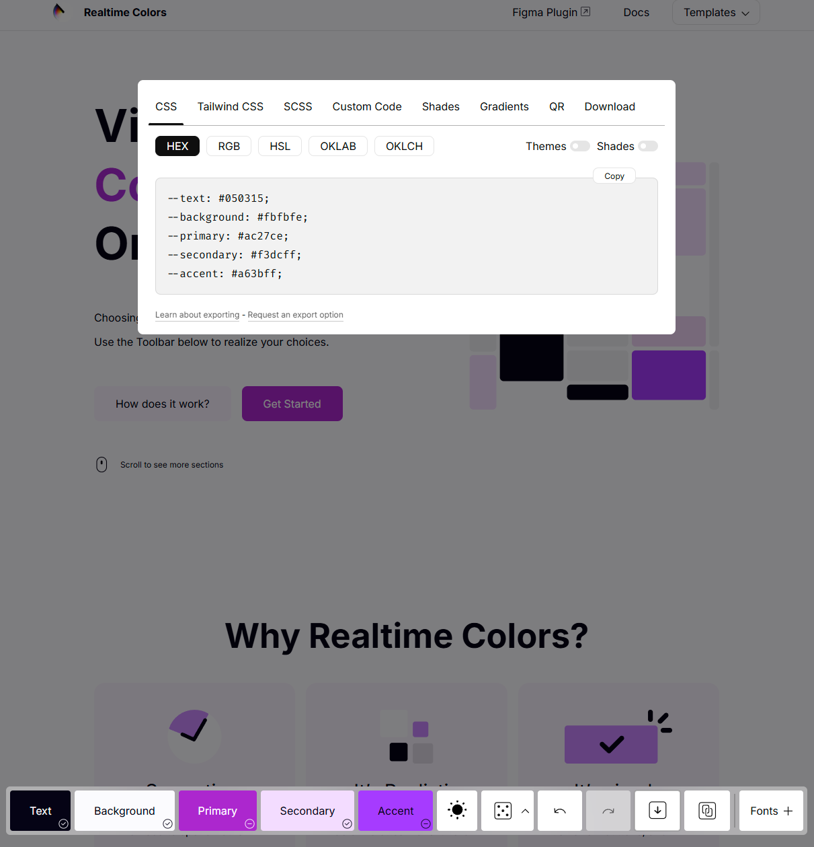

- How will your project use a form? (20 points)
Describe how you plan to use a form in your project to collect viewers’ inputs or information:
- List the purpose of that form: Examples of using a form might be to offer feedback, provide a survey or poll, offer subscriptions to a newsletter, etc. (4 points)
- Describe what information you want to collect from your viewers. For this project, you will need to collect at least 4 inputs from your viewers (suck as name, email, comments, etc.) (8 points)
- Explain the importance of each piece of information (8 points)
Purpose of the Form:
The form will allow visitors, especially potential employers or collaborators, to contact me directly for questions, job opportunities, or project inquiries. It serves as an easy way for viewers to connect with me without leaving the site.
Information to Collect (at least 4 inputs):
- Name – so I can address the person professionally.
- Email Address – to respond or follow up on opportunities.
- Company/Organization (optional) – helps me understand if the inquiry is professional or collaborative.
- Message/Comments – lets the viewer explain their purpose for contacting me.
Importance of Each Piece of Information:
- Name: Creates a personal and professional tone when replying.
- Email: Essential for maintaining communication and potential job offers.
- Company/Organization: Provides context for the inquiry (e.g., internship, collaboration, job offer).
- Message/Comments: Allows the sender to share their needs, feedback, or reasons for reaching out.

